Name: LEON KIMUTAI LANGAT.
Student_Id: GH1046169.

APPLIED STATISTICAL MODELLING PROJECT.
GitHub Link:

1. Introduction
The purpose of this analysis is to investigate the factors associated with profitability in the Superstore dataset. The analysis focuses on three potential explanatory variables: Discount, Sales, and Quantity. A multiple linear regression model is used to examine how these variables are associated with Profit while controlling the other variables in the model.
The dataset contains 9,994 observations and 22 variables, covering information about orders, customers, products, sales, discounts, quantities, and profits. Exploratory data analysis is first conducted to understand the characteristics of the data and identify important patterns. This is followed by regression analysis and diagnostic testing to assess the reliability of the model.
The analysis also uses HC3 robust standard errors because the diagnostic tests indicated the presence of heteroscedasticity. The findings are used to provide practical business recommendations concerning discounts, sales performance, and profitability.

2. Methodology
2.1 Data Preparation
The analysis was conducted using the Superstore dataset, which contains 9,994 observations and 22 variables. The dataset includes information on sales transactions, products, customers, discounts, quantities, and profits.
The dependent variable for the analysis was Profit, while the independent variables were Discount, Sales, and Quantity. Missing-value checks were performed before the analysis. The only missing values identified were in the Postal. Code variable. Since Postal Code was not used in the regression model, these missing values did not affect the regression analysis.
2.2 Exploratory Data Analysis
Exploratory data analysis (EDA) was conducted to understand the distribution of Profit and examine patterns within the dataset. Summary statistics, frequency tables, and aggregated profit measures were used.
The analysis showed that Profit ranged from approximately −6,599.98 to 8,399.98, with a mean of 28.66 and a median of 8.67. The difference between the mean and median, together with the extreme minimum and maximum values, suggests that the distribution of Profit is affected by extreme observations.
Profits were also examined across product categories, regions, and customer segments to identify differences in profitability.
2.3 Multiple Linear Regression
A multiple linear regression model was estimated using the following specification:
Profit = β₀ + β₁(Discount) + β₂(Sales) + β₃(Quantity) + ε
The model was estimated in R using:
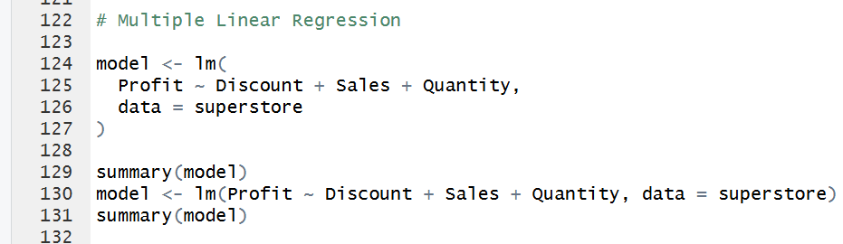
The purpose of the regression was to determine whether Discount, Sales, and Quantity were statistically associated with Profit while holding the other explanatory variables constant.
2.4 Hypotheses
The following hypotheses were tested:
Discount
- H₀: Discount has no significant association with Profit.
- H₁: Discount has a significant association with Profit.
Sales
- H₀: Sales has no significant association with Profit.
- H₁: Sales has a significant association with Profit.
Quantity
- H₀: Quantity has no significant association with Profit.
- H₁: Quantity has a significant association with Profit.
2.5 Model Diagnostics
Regression diagnostic tests and plots were used to assess the assumptions of the linear regression model. These included examination of:
- Linearity
- Homoscedasticity
- Normality of residuals
- Potential influential observations
- Multicollinearity
The diagnostic results indicated heteroscedasticity and departures from normality in the residuals. Some observations also appeared potentially influential. Therefore, these issues were considered when interpreting the regression results.
2.6 Robust Statistical Inference
Because heteroscedasticity was detected, HC3 heteroscedasticity-robust standard errors were used when testing the individual regression coefficients.
The robust inference was calculated in R using:
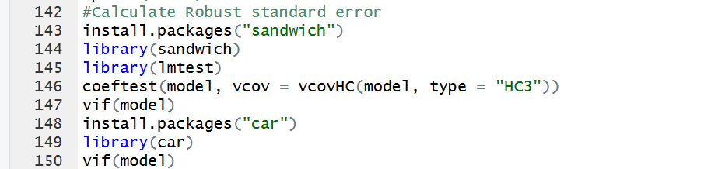
Variance Inflation Factors (VIFs) were also calculated to assess multicollinearity. All VIF values were close to 1, indicating that there was no meaningful multicollinearity among Discount, Sales, and Quantity.

3. Exploratory Data Analysis (EDA)

3.1 Profit Distribution
The descriptive statistics for Profit were:
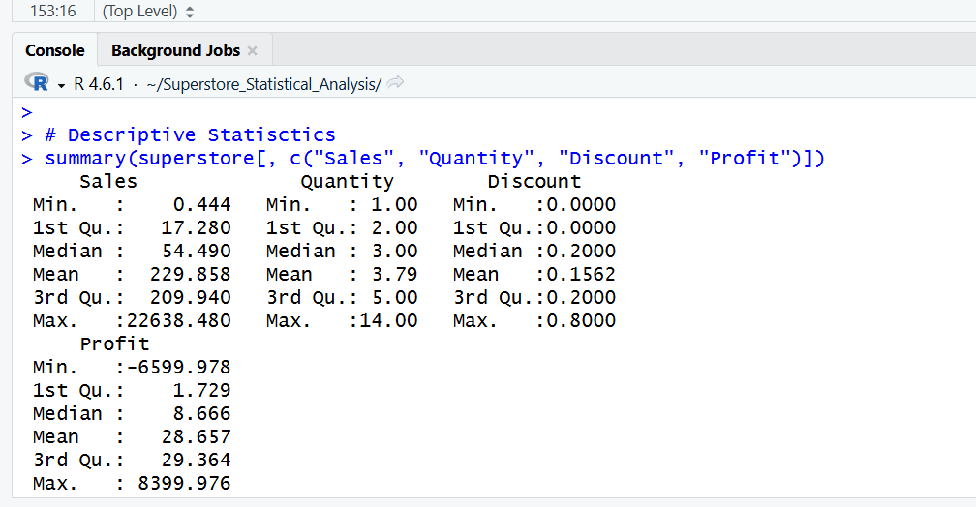

Profits have a relatively wide range, from substantial losses to substantial gains. The mean profit (28.66) is higher than the median (8.67), suggesting that some high-profit observations influence the overall average. The large minimum and maximum values also indicate the presence of extreme observations.
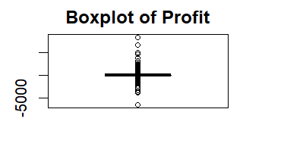

3.2 Profit by Product Category
The total profit for each product category was:
Category | Total Profit
Furniture | 18,451.27
Office Supplies | 122,490.80
Technology | 145,454.95
Technology generated the highest total profit, with approximately 145,454.95, followed by Office Supplies with 122,490.80. Furniture generated considerably less total profit, at 18,451.27.
This suggests that product category is potentially important when considering overall business profitability. However, these are descriptive totals and do not by themselves establish that category causes higher or lower profit.
3.3 Number of Observations by Category
The number of transactions in each category was:
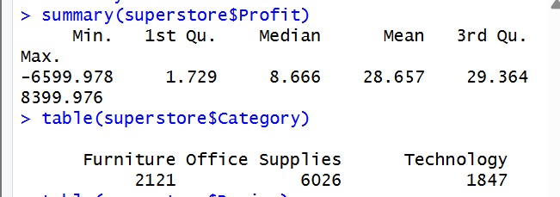
Office Supplies had the largest number of observations, while Technology had fewer observations but the highest total profit. This indicates that the number of transactions alone does not necessarily determine total profitability.

3.4 Regional Distribution
The observations were distributed across four regions:
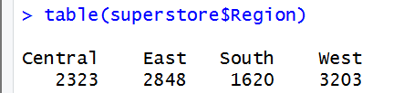

The West region had the largest number of observations, while the South had the smallest. These differences in transaction volume should be considered when comparing regional business performance.

3.5 Customer Segment Distribution
The dataset contained three customer segments:
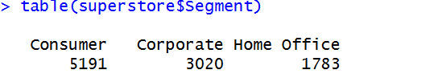
The Consumer segment represented the largest proportion of observations, followed by Corporate and Home Office customers.
3.6 Highest-Profit Transactions
The highest-profit transactions in the dataset generated approximately 8,399.98 in profit. It involved a Canon image CLASS 2200 Advanced Copier, with sales of approximately 17,499.95, a 0% discount, and a quantity of 5.
Several of the other highest-profit transactions also involved high-value technology products, particularly printers and copiers. This provides a useful descriptive indication that high-value technology products can generate substantial profits.
However, these individual transactions should not be interpreted as evidence of causality.

4. Regression Results
4.1 Overall Model
A multiple linear regression was conducted to examine the relationship between Profit and the three explanatory variables: Discount, Sales, and Quantity.
The overall regression model was statistically significant:
F (3, 9990) = 1249, p < 0.001
The model produced an R² of 0.2727 and an adjusted R² of 0.2725. This means that approximately 27.27% of the variation in Profit is explained by Discount, Sales, and Quantity in the model. The remaining variation is associated with other factors that are not included in the model.
4.2 Regression Coefficients
Because heteroscedasticity was detected during the diagnostic analysis, HC3 robust standard errors were used for interpreting the individual coefficients.
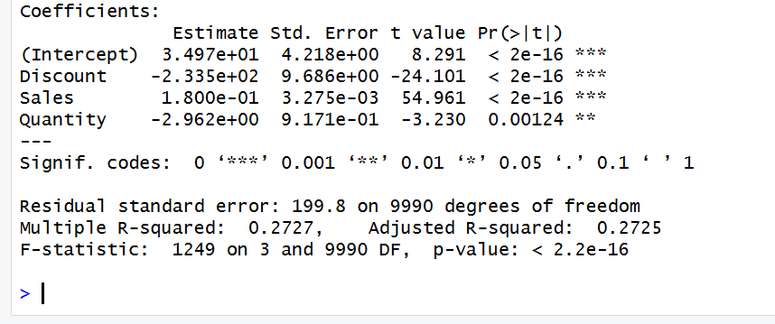

4.3 Discount
Discount has a negative and statistically significant association with Profit (β = −233.46, p < 0.001).
Holding Sales and Quantity constant, a one-unit increase in the discount proportion is associated with an estimated 233.46-unit decrease in Profit.
For a more realistic interpretation, a 10 percentage-point increase in discount (0.10) is associated with approximately:
−233.46 × 0.10 = −23.35
Therefore, a 10 percentage-point increase in discount is associated with approximately 23.35 lower profit, holding the other variables constant.
The 95% confidence interval does not include zero, providing further evidence of a statistically significant relationship.
4.4 Sales
Sales have a positive and statistically significant association with Profit (β = 0.180, p = 0.00127).
Holding Discount and Quantity constant, a one-unit increase in Sales is associated with an estimated 0.18-unit increase in Profit.
The 95% confidence interval ranges from approximately 0.071 to 0.289, which does not include zero.
Therefore, the null hypothesis that Sales has no significant association with Profit is rejected.
4.5 Quantity
Quantity has a negative estimated coefficient of −2.96, but the relationship is not statistically significant when using HC3 robust standard errors (p = 0.296).
The 95% confidence interval ranges from −8.52 to 2.59 and includes zero.
Therefore, the null hypothesis that Quantity has no significant association with Profit is not rejected.
This means that the analysis does not provide sufficient statistical evidence that Quantity has an independent relationship with Profit after controlling for Discount and Sales.
4.6 Hypothesis Decisions
Variable | Decision | Conclusion
Discount | Reject H₀ | Significant relationship with Profit
Sales | Reject H₀ | Significant relationship with Profit
Quantity | Fail to reject H₀ | No statistically significant relationship detected
4.7 Multicollinearity
The VIF values were:
- Discount = 1.001
- Sales = 1.043
- Quantity = 1.042
All values are very close to 1, indicating no problematic multicollinearity among the explanatory variables.

5. Diagnostic Results and Model Assumptions
5.1 Linearity
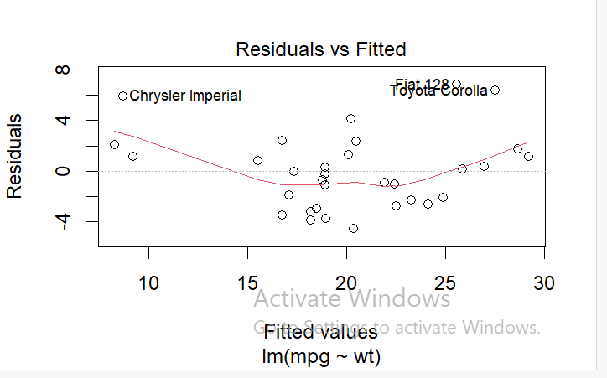
The Residuals vs Fitted plot was examined to assess whether the relationship between the predictors and Profit was reasonably linear. The plot showed some systematic variation in the residuals, particularly as fitted values increased. This suggests that the linear model may not capture all patterns in the data.

5.2 Homoscedasticity
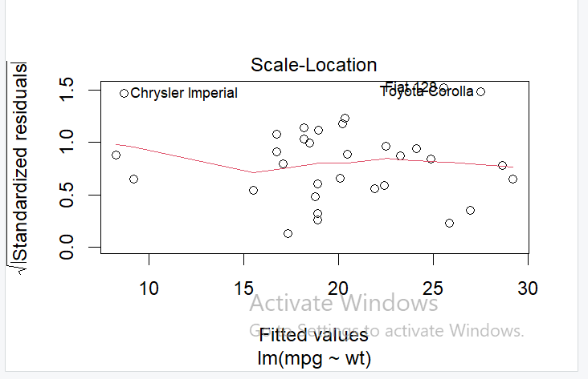
The diagnostic plots indicated that the variance of the residuals was not constant across fitted values. In particular, the spread of residuals increased for larger fitted values.
This indicates the presence of heteroscedasticity, which violates one of the standard assumptions of ordinary least squares regression.
Because of this issue, HC3 robust standard errors were used for the coefficient tests. These provide more reliable standard errors when heteroscedasticity is present.

5.3 Normality of Residuals
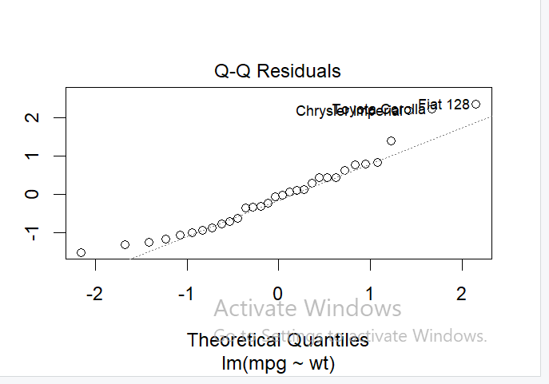
The Q-Q plot showed substantial departures from the theoretical normal distribution, particularly in the tails. This indicates that the residuals are not perfectly normally distributed.
The large range of Profit and the presence of extreme observations are likely contributing to this departure.

5.4 Influential Observations
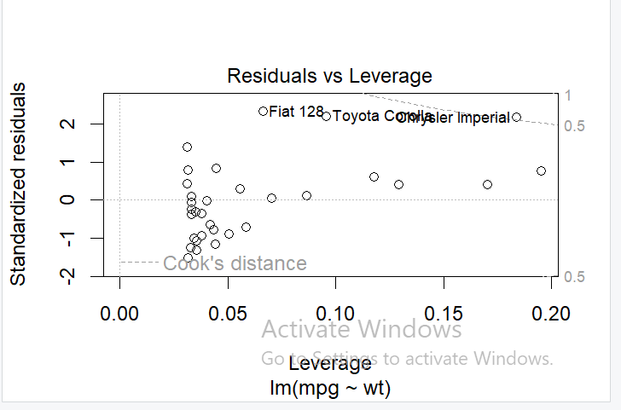
The Residuals vs Leverage diagnostic indicated several observations that may have relatively high leverage or influence on the regression model. Some observations, including observations around 8154, 6827, and 2698, appeared unusual in the diagnostic plots.
These observations should not automatically be removed because an observation being unusual does not mean it is incorrect. They may represent genuine high-value transactions in the Superstore data.

5.5 Multicollinearity
The VIF values were all close to 1:
Predictor | VIF
Discount | 1.001
Sales | 1.043
Quantity | 1.042
Therefore, there is no evidence of problematic multicollinearity among the independent variables.

6. Business Interpretation and Recommendations
6.1 Business Interpretation
The regression results provide several important insights into the factors associated with profitability.
Discounts have the strongest negative relationship with Profit. The robust coefficient of −233.46 indicates that higher discounts are associated with lower profits, after controlling Sales and Quantity. This suggests that excessive discounts may reduce the amount of profit made from sales.
Sales have a positive and statistically significant relationship with Profit. The coefficient of 0.180 indicates that higher sales are associated with higher profit when Discount and Quantity are held constant. However, increasing sales alone does not necessarily guarantee high profitability because profit margins and discount levels also matter.
Quantity was not statistically significant using robust standard errors (p = 0.296). Therefore, there is insufficient evidence to conclude that selling a greater number of units independently increases or decreases Profit after controlling for Sales and Discount.

6.2 Recommendations
Based on the findings, the following recommendations can be made:
1. Control excessive discounting
The company should carefully review its discount strategy because Discount has a strong negative association with Profit. Discounts should be targeted toward products or customers where they are likely to generate sufficient additional sales to compensate for the reduced margin.
2. Focus on profitable sales rather than sales volume alone
Since Sales are positively associated with Profit, increasing sales can support profitability. However, management should focus on profitable sales, rather than simply maximizing revenue.
3. Review of product pricing and margins
The results suggest that pricing decisions are important. Management should identify products with strong profit margins and avoid relying heavily on discounts for products that already have limited margins.
4. Do not use Quantity as the main profitability target
Because Quantity was not statistically significant in the robust model, simply increasing the number of units sold should not be treated as the primary strategy for increasing profit. The company should instead consider product mix, pricing, sales value, and discount levels.
5. Investigate high-profit products
Technology generated the highest total profit in the exploratory analysis. Management could investigate which technology products, particularly high-value products, generate strong margins and consider whether similar strategies can be applied to other product categories.
6.3 Overall Business Implication
Overall, the findings suggest that profitability is more closely associated with the value of sales and the level of discount than with the number of units sold. A business strategy focused on increasing sales while maintaining healthy margins and controlling unnecessary discounts may therefore be more effective than simply trying to increase sales quantity.
Important: These findings represent statistical associations, not proof that changing discounts or sales will directly cause a particular change in profit. The dataset is observational, so causal conclusions cannot be established from this regression alone.

7. Limitations
7.1 Limitations of the Analysis
Several limitations should be considered when interpreting the results.
1. Observational data
The dataset contains historical business transactions. Therefore, regression identifies associations rather than causal relationships. For example, the negative coefficient for Discount does not prove that increasing a discount will always cause profit to decrease.
2. Limited explanatory power
The model has an R² of 0.2727, meaning that approximately 27.27% of the variation in Profit is explained by Discount, Sales, and Quantity. Therefore, approximately 72.73% of the variation is related to other factors not included in the model.
3. Heteroscedasticity
The diagnostic analysis identified heteroscedasticity. This means that the variability of the regression errors is not constant across observations. HC3 robust standard errors were therefore used to make the coefficient inference more reliable.
4. Non-normal residuals
The Q-Q plot showed departures from normality, particularly in the tails. This may be partly related to extreme profit and loss observations.
5. Potentially influential observations
Some observations appeared unusual in leverage and residual diagnostics. These may have an important effect on the estimated regression coefficients. However, they were not automatically removed because they may represent genuine business transactions.
6. Variables not included in the model
Profit may also depend on factors such as product category, sub-category, region, customer segment, shipping mode, product type, and time-related effects. These variables were not included in the main regression model and could explain some of the remaining variations in Profit.
8. Conclusion
This study examined the relationship between Profit, Discount, Sales, and Quantity using multiple linear regression on the Superstore dataset.
The overall regression model was statistically significant, F(3, 9990) = 1249, p < 0.001, and explained approximately 27.27% of the variation in Profit.
The results, using HC3 robust standard errors, showed that Discount and Sales were statistically significant predictors of Profit. Discounts had a negative association with Profit, while Sales had a positive association with Profit. In contrast, Quantity was not statistically significant after accounting for heteroscedasticity.
The findings suggest that businesses should pay particular attention to discount management and profitable sales growth. Simply increasing the quantity of products sold may not necessarily improve profitability. Management should instead consider pricing, margins, product mix, and discount strategies.
Overall, the analysis provides useful evidence for understanding profitability in the Superstore dataset, while recognizing that the results represent statistical associations rather than causal effects. Future analysis could improve the model by incorporating additional variables such as product category, region, customer segment, and time trends.

